ILI9341 with touch screen
A) Display
B) Touch screen

A)
1) Drag all .h and .c files into the appropriate folders, see image:
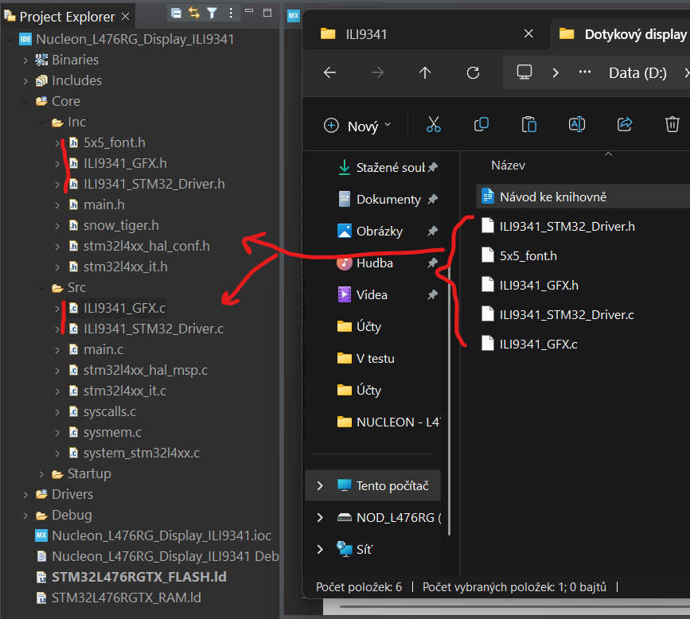

2) In all files that were uploaded to stm, check and possibly rewrite the include according to the processor you are using (the default is, for example, for the NUCLEON L476RG kit:
#include "stm32l4xx_hal.h"

3) In the next step, set the SPI according to your choice, for example like this:
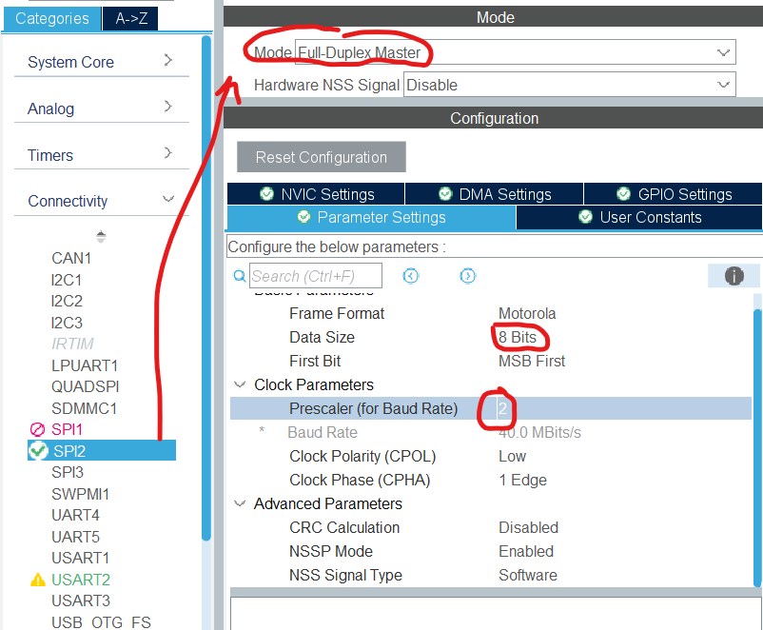

4) Next, set 3 pins as RESET, DC and SS outputs.

5) In this step, rewrite these lines in the ILI9341_STM32_Driver.h library for the selected SPI interface (just rewrite the number 2x in hspi2 according to the number of the spi interface you selected) and then set the pins and ports you selected for reset, DC and SS from step 4:
extern SPI_HandleTypeDef hspi2;
#define HSPI_INSTANCE &hspi2

//CHIP SELECT PIN AND PORT, STANDARD GPIO
#define LCD_CS_PORT GPIOA
#define LCD_CS_PIN GPIO_PIN_0

//DATA COMMAND PIN AND PORT, STANDARD GPIO
#define LCD_DC_PORT GPIOA
#define LCD_DC_PIN GPIO_PIN_1

//RESET PIN AND PORT, STANDARD GPIO
#define LCD_RST_PORT GPIOA
#define LCD_RST_PIN GPIO_PIN_4

6) Testovací kód:
a) Vlož knihovny do include:
#include "ILI9341_STM32_Driver.h"
#include "ILI9341_GFX.h"
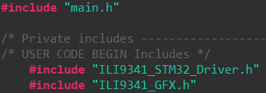

b) Somewhere above the main while loop in the user code, insert:
ILI9341_Init();
ILI9341_Set_Rotation(3);
ILI9341_Fill_Screen(GREEN);
ILI9341_Draw_Text("Ahoj svete!", 50, 50, WHITE, 2,BLACK);

A)
1) Drag all .h and .c files into the appropriate folders, see image:
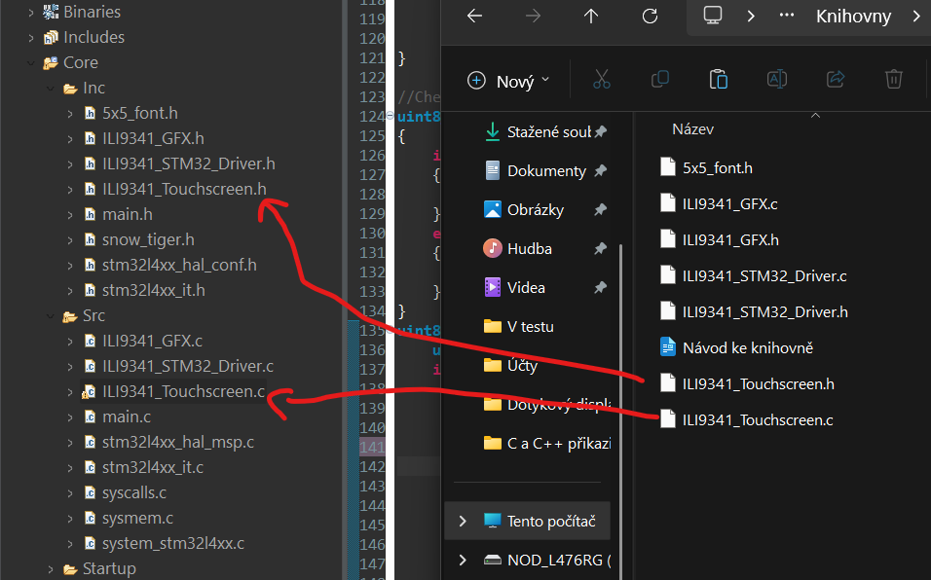

2)In all files that were uploaded to stm, check and possibly rewrite the include according to the processor you are using (the default is, for example, for the NUCLEON L476RG kit:
#include "stm32l4xx_hal.h"

3) In the next step, set up five pins in the GUI according to the instructions in the ILI9341_Touchscreen.h file according to the requirements as in the file, see for example:
// output (T_CLK)
#define TP_CLK_PORT GPIOC
#define TP_CLK_PIN GPIO_PIN_7
// output (T_CS)
#define TP_CS_PORT GPIOB
#define TP_CS_PIN GPIO_PIN_8
// input (T_DO)
#define TP_MISO_PORT GPIOA
#define TP_MISO_PIN GPIO_PIN_7
// output (T_DIN)
#define TP_MOSI_PORT GPIOB
#define TP_MOSI_PIN GPIO_PIN_9
// input (T_IRQ)
#define TP_IRQ_PORT GPIOA
#define TP_IRQ_PIN GPIO_PIN_6

4) The test code is:
a) Put the libraries in include:
#include "ILI9341_Touchscreen.h"

b) Somewhere above the main while loop or inside it, insert it into the user code (the coordinates are returned well from the point of view of setting 3 using the ILI9341_Set_Rotation(3); from the display library) the TP_Touchpad_Dej_XY(XY) function can be modified, you wrote it because of the stupid values ​​returned by the display):
uint16_t XY[2]={0};
uint16_t x=0,y=0;
if (TP_Touchpad_Dej_XY(XY)==1){
x=XY[0];
y=XY[1];
}
}
*coordinates [0,0] are in the corner closest to the orange cables entering the touch display.

